System Variables
UCF Development Notes v102922
Richard Todd
Test Engineering Services
Requires StdIOChannelSystem(.so | dll) v112922 or later.

Description
System variables provide an alternative to hardcoded system configuration values.
The following types of variables are supported
◇ Global variables that are common to all profiles
◇ Local variables that are common to a specific profile group
Local variables will always override global variables of the same name.
Data Locations
System variables are stored in sqlite databases.
◇ Local variables are stored in the ‘SystemVariables’ table in (./opt/<Profile Family>/ExtSystemIO.sdb)
◇ Global variables are stored in the ‘SystemVariables’ table in (./bin/<Release Name>/BaseSystemIO.sdb)
Configuring System Variables
System variables are created and updated using the sqlitebrowser utility.
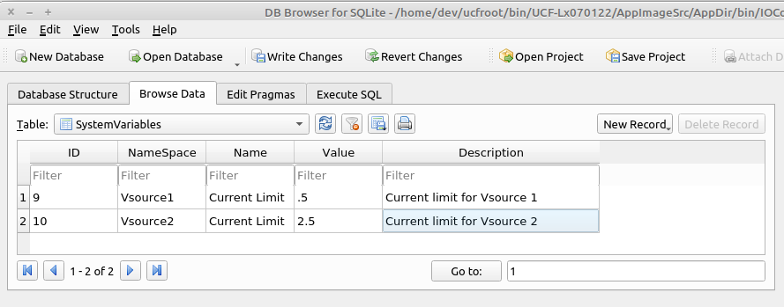

Reading System Variables
The value(s) for system variables are read programmatically using the ‘GetSystemVariable(...)’ functions defined in iStdIOChannelSystem.hpp
Example 1: bool status=TheSystem->GetSystemVariable(..);
/* TheSystem is an iStdIOChannelSystem*
1. status will be true if the variable is found, and false if not
*/

Example 2:

int TplModule::TestSystemVariables(CmdParam msg) {
std::string ns, name, value, desc;
char cvalue[256];
memset(cvalue,0,256);

TokenString params(msg,',');
if (params.GetTokenCount() > 3) {
params.GetToken(1, ns);
params.GetToken(2, name);
params.GetToken(3, value);
params.GetToken(4, desc);
TheSystem->GetSystemVariable(ns.c_str(), name.c_str(),cvalue,256);
}
return(1);
}

